**Project Proposal Antique-Book**

Shop4U is a leading online retailer of rare and antique books. Thousands of rare, out-of-print, first edition, vintage, and signed books are available through the global network of trustworthy bookstores. This project focuses on development of a website for selling antique books. There are three website users include admin, bookstore and customers. Basically, the administrator is responsible for removing, adding as well as banning users. He is also responsible updating web content, password reset and database management. On the other hand, the bookstores either accepts of rejects offers and can add or remove friends. Finally the users can view available books and make a purchase. The main aim of this paper is to provide a technical document for the report.

**Programming languages Utilized**

To develop the website for Shop4U, the following programming languages have been utilized:

1. PHP - PHP is a server-side scripting language that has grown in popularity as its performance and functionality have improved. Because of its compatibility with HTML and databases, PHP is an excellent choice for anyone looking to create dynamic websites.
2. MySQL - MySQL is a relational database management system that is based on the Structured Query Language. Structured Query Language is the most common language for accessing and managing the records in a database. MySQL is based on Structured Query Language. Under the GNU license, MySQL is a piece of software that is both open-source and free. Oracle Corporation provides support for it.

MySQL provided assistance in managing databases and aids in the manipulation of data by utilizing a variety of SQL queries. These queries include things like inserting records, updating records, and deleting records, selecting records, creating tables, and dropping tables, amongst other things.

1. **HTML -** For every web page, the skeleton is made out of HTML. Developers, marketers, and designers commonly learn it as their first programming language, and it's essential to front-end development.

A website's content, such as images, text, and videos, can be organized using HTML. Click "Inspect" from the context menu of any web page you're viewing to have the page's HTML code displayed in a separate window.

1. **CSS** - Cascading style sheets, or CSS, is what it means. For the most part, CSS is a design language that enhances the visual attractiveness of a website, rather than making it look like nothing more than a collection of words. CSS, on the other hand, is primarily responsible for determining the visual structure, layout, and aesthetics of a website. CSS is a style sheet language, whereas HTML is a markup language. When you think of CSS, think of how it will appear and feel. CSS is like the body and paint on a car: HTML is the engine, and CSS is the body. CSS is not required for a website to function, but it does make it seem shabby. CSS enhances the look and feel of a website's front end and facilitates an enjoyable browsing experience for its visitors. Without CSS, websites would be less visually appealing and more difficult to use. Also responsible for font color, CSS is responsible for layout and format.

**Website Explanation**

**The Homepage**

The following figure 1.0 shows the screenshot of the homepage:

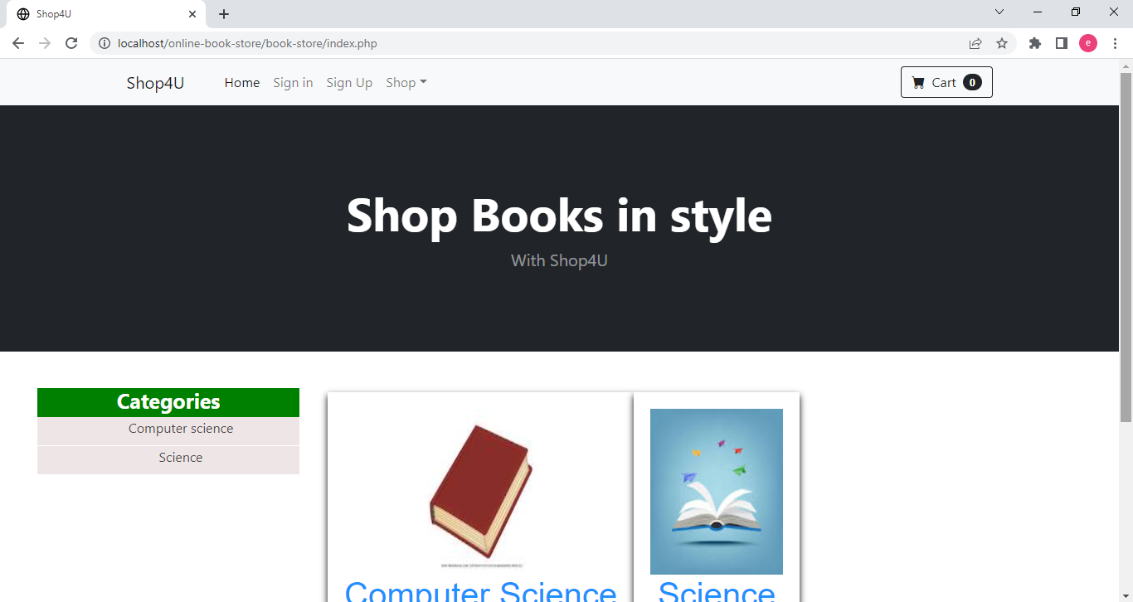

Figure 1.0: Screenshot of homepage

The homepage of the website entails a sign in and sign up for the customers and bookstores. The admin doesn’t sign up to the website, but only sign in. The following figure 2.0 and 3.0 shows the screenshot of sign up and sign in pages, respectively:

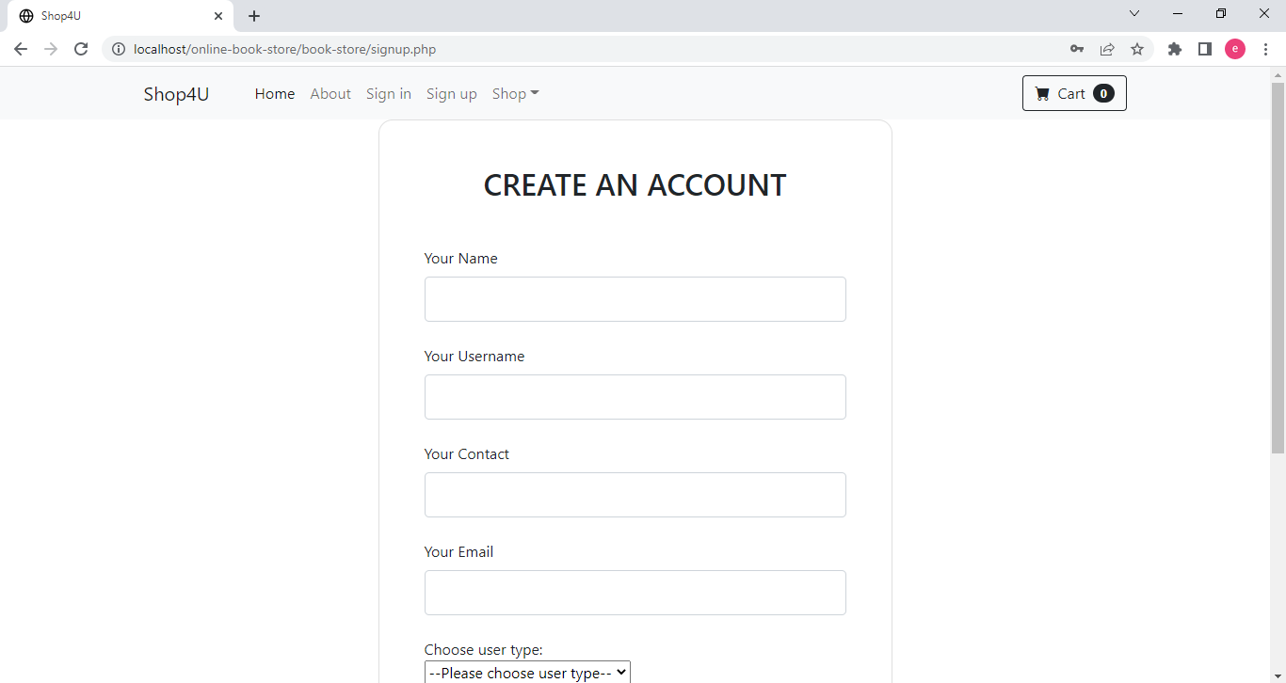

*Figure 2.0 – Sign up page*

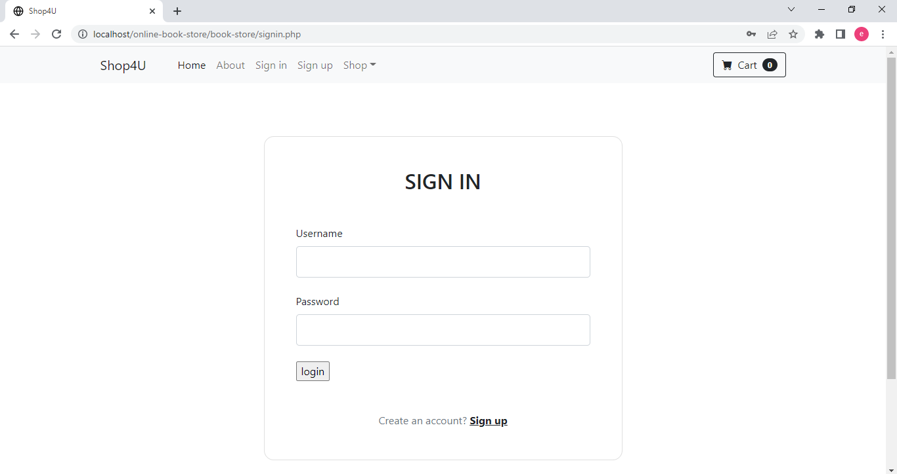

*Figure 3.0 – Sign in Page*

The user must provide correct username and password so sign in to the Shop4U website. When a user has provided wrong username and password the following message appears “Wrong username and password!!” as shown below:

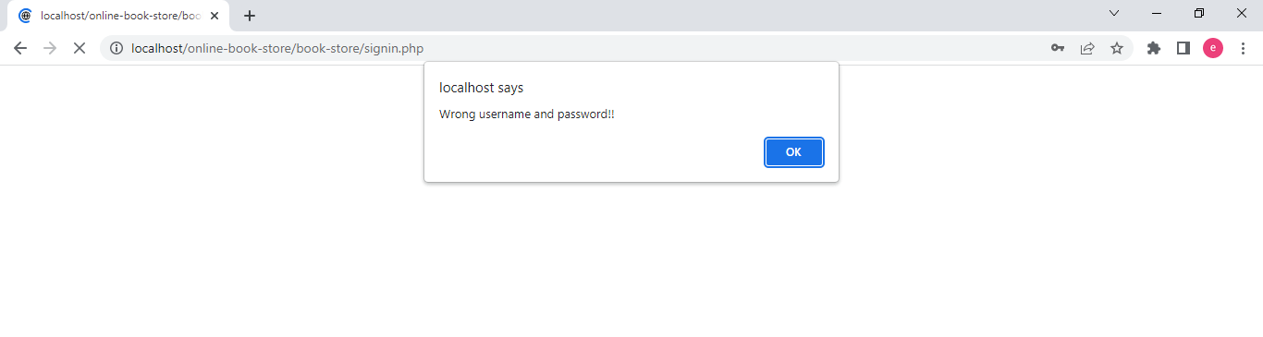

*Figure 4.0 – Screenshot showing wrong username and password*

**Administrator Page**

The following screenshot 5.0 shows the landing page of the administrator:

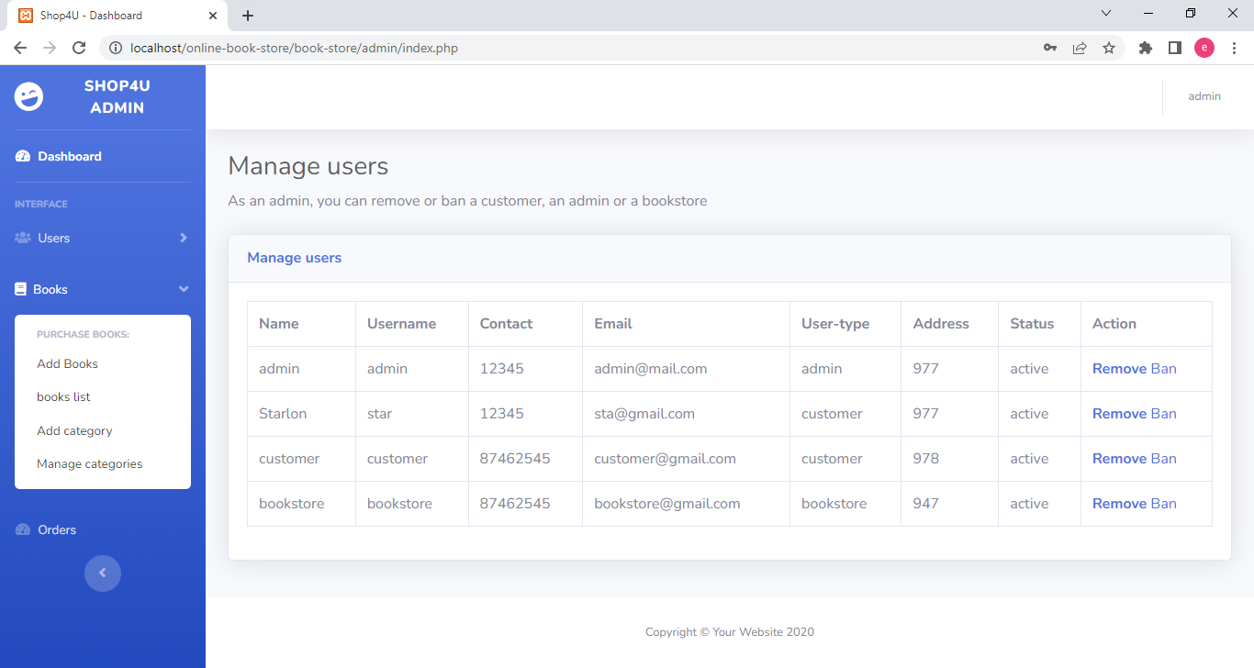

*Figure 5.0: Landing page of the administrator*

The landing page shows the manage users. This is one of the roles of the administrator. The administrator can remove or ban users as well. On the left side of the page, the administrator have other roles in the books section; including but isn’t limited to viewing book list, add book categories, manage book categories, and adding a new book. The following screenshots shown an admin adding a new book successfully:

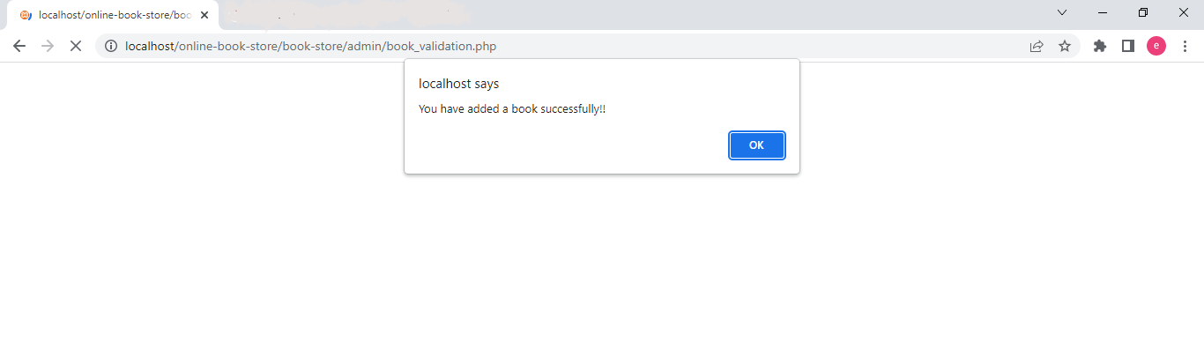

*Figure 6.0: Successful addition of a new boom by the admin*

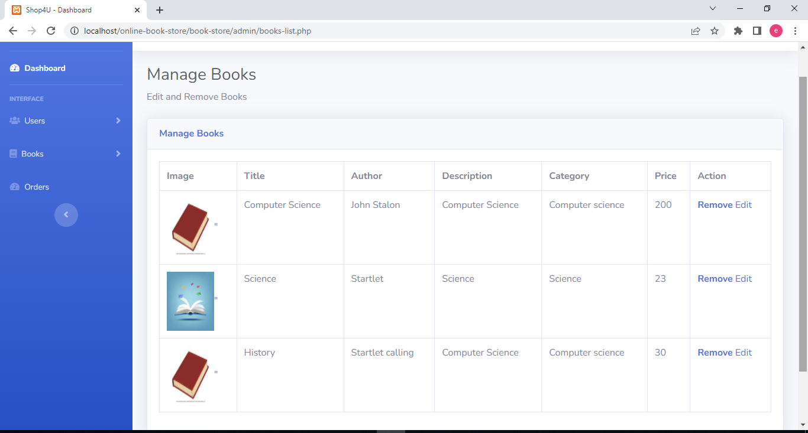

*Figure 7.0: A new book has been added to the list*

As seen above, the administrator can remove a given book or edit its details. Still on the above figure 7.0, the administrator can see customers’ orders.

Finally the administrator can click the name admin on the right top of the page to edit profile and logout as shown in figure 8.0 below:

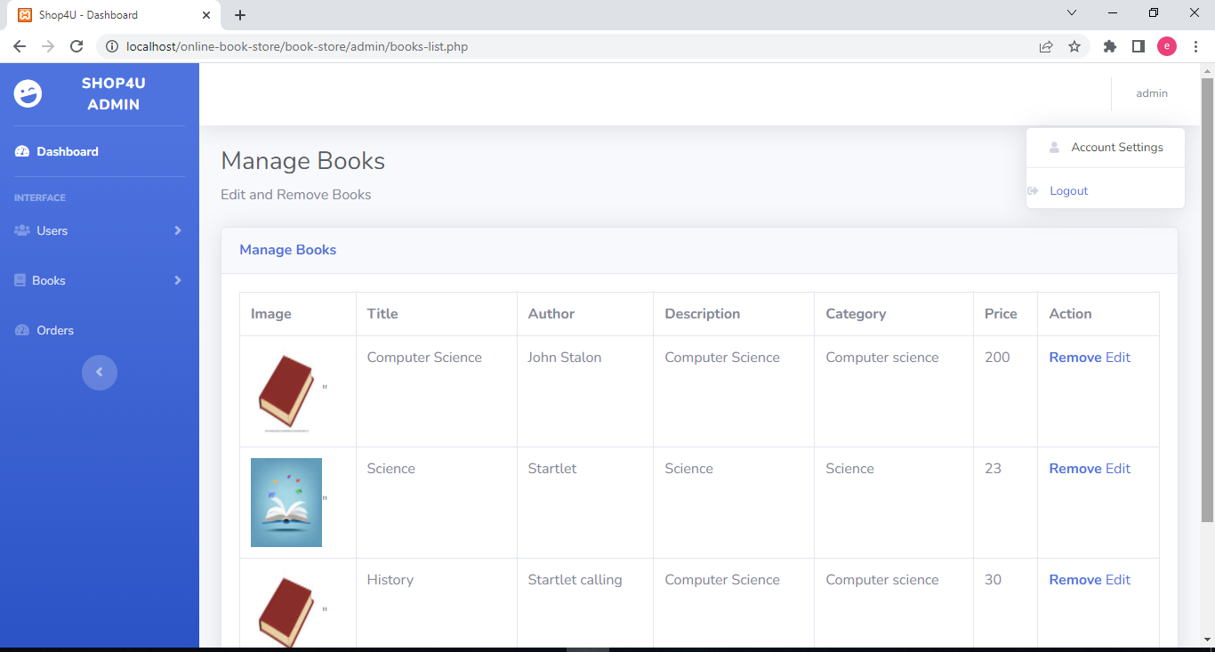

*Figure 8.0: Screenshot showing admin can manage account and logout*

**Bookstore Page**

The following figure 9.0 shows the screenshot of the landing page for the bookstore after a successful sign in:

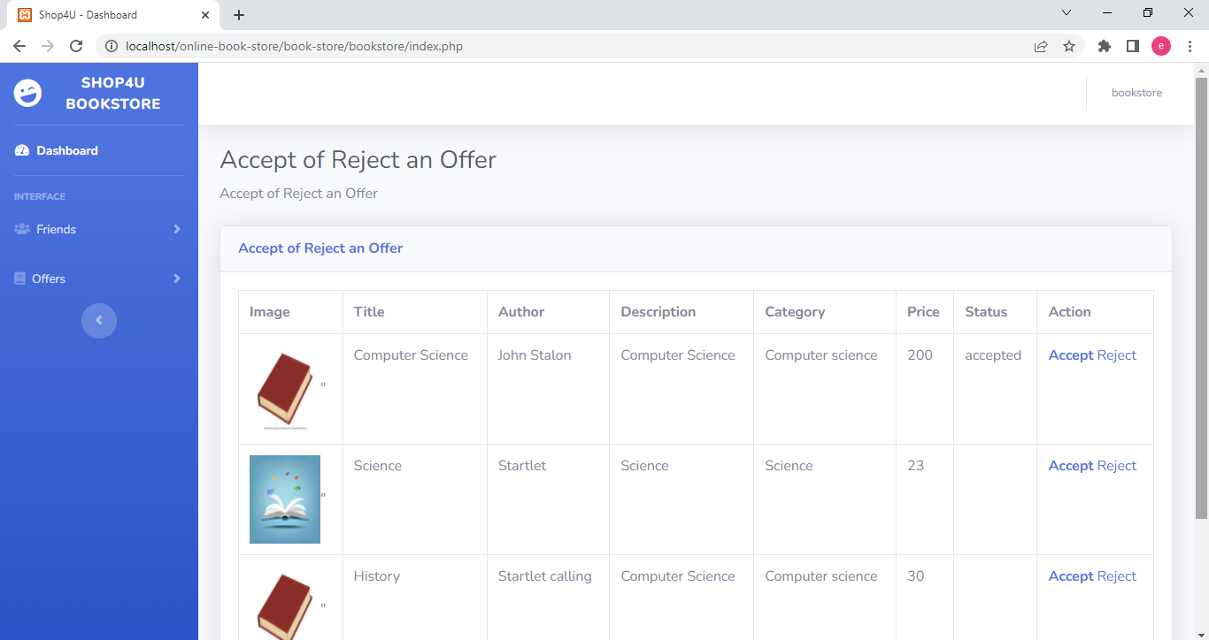

*Figure 9.0: Landing page of the bookstore*

From the above figure 9.0, it can be observed that the bookstore can accept or reject an offer of selling a particular book. The bookstore can also add and remove a friend. Like the admin, the bookstore can edit profile and logout by clicking the bookstore name at the top right corner of the web page.

**Customer Page**

The last user of this website is the customer, who can view the products and make a purchase. The following screenshot shows the landing page of customer:

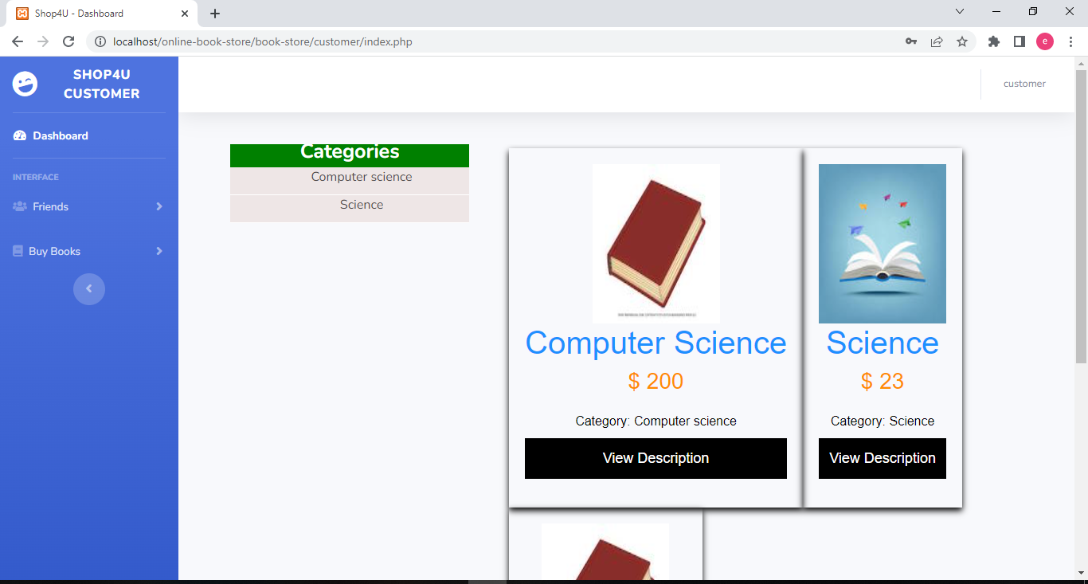

*Figure 10.0: Screenshot showing landing page of the customer*

The customers can view books based on the categories, by clicking a particular category such as computer science as seen from the above screenshot. The customer can view the description of particular book to get more information about it. On the left sidebar, the customer can click friends’ option to add or remove friends. Like the bookstore and the admin, the customer can click on his name at the right top corner to edit profile or logout of the website.

**Conclusion**

In conclusion, this project deliberated the development of Shop4U website for selling rare as well as antique books. Some of the language used for the development include PHP, HTML, CSS and MySQL. The website consists of three users including administrator, bookstore and customers. Roles of admin include adding and banning users, while the bookstore accepts or rejects an offer of selling a particular book. Finally, the customer can view books and make purchase.